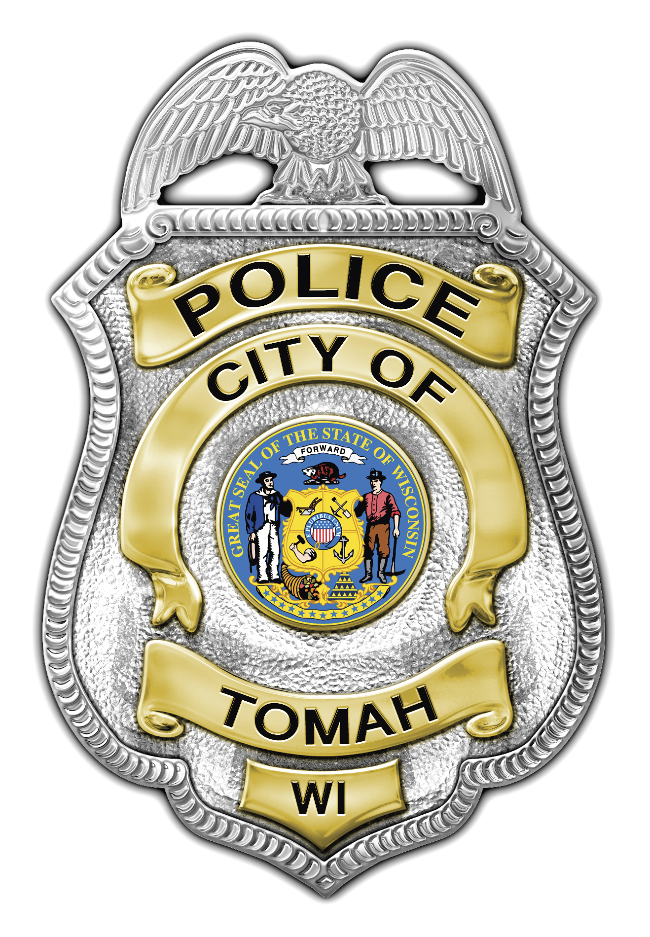
Wesley D. Revels
Chief of Police

Tomah Police Department

805 Superior Avenue

Tomah, Wisconsin 54660

Phone (608) 374-7400

Fax (608) 374-7413

tomahpd@tomahpolice.com

__________________________________________

NEWS RELEASE

Incident Type: Residential Burglary and Theft

Incident Date: July 31, 2012

Incident Location: City of Tomah, Southside residence

Incident Brief:

On August 31, 2012 at approximately 11:30 a.m. the Tomah Police Department responded to a residence located on the south side of Tomah. The owner reported a burglary to the residence and the theft of several items.

It was determined that during the hours of 10:00 a.m. and 11:15 a.m. unknown subject(s) forced their way into the residence through a door. The items reported missing included jewelry and electronics.

If you have information about this case you are encouraged to contact Officer Brittnay Westpfahl or Detective Robert Walensky of the Tomah Police Department. They may be contacted at 608 374-7400.

If you wish to remain anonymous and you have information about this crime you may call the Monroe County Crime Stoppers at 608-269-7867 or 608-372-7867. Callers are eligible for a reward up to $1,000.

