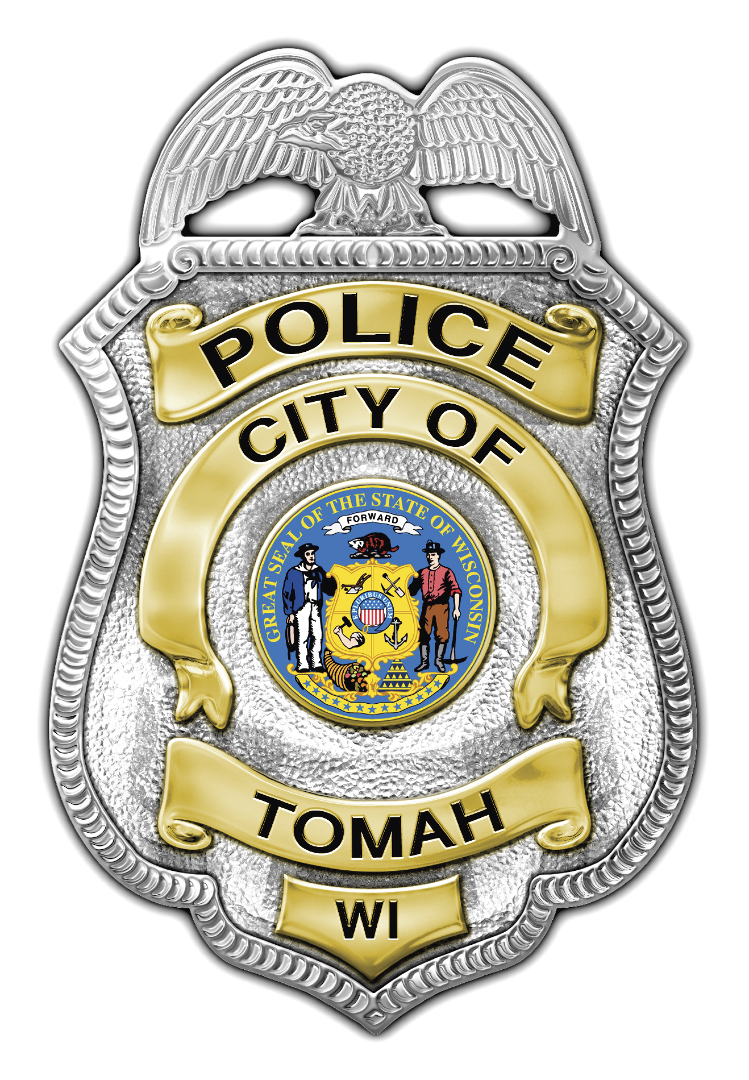
Mark D. Nicholson
Chief of Police

Tomah Police Department

805 Superior Avenue

Tomah, Wisconsin 54660

Phone (608) 374-7400

Fax (608) 374-7413

tomahpd@tomahpolice.com

_____________________________________________________________
Tomah PD - NEWS RELEASE
Incident Type: Two Vehicle - Injury Accident
Incident Date/Time: September 5, 2015 / 8:10PM
Incident Location: N Superior Ave (US HWY 12) at W McCoy Blvd (STH 21), City of Tomah
Driver #1: Female, Age 16, Rural Tomah, WI
Vehicle #1: 2002 Buick LeSabre - Silver
Driver #2: Female, Age 41, Rural Tomah, WI
Vehicle #2: 2005 Chevy Trailblazer - Silver
Details:
On September 5, 2015, at approximately 8:10PM, the Tomah Police Department was dispatched to the intersection of N Superior Ave and W McCoy Blvd for a two vehicle accident with injuries. Upon arrival, it appeared that both vehicles sustained significant front end damage in the southbound lanes of N Superior Ave. Driver #1 had to be extricated from the vehicle. Due to the potential serious head injuries that appeared to Driver #1, the Wisconsin State Patrol Traffic Reconstruction Unit was requested to respond to the scene.
Both drivers were transported to Tomah Memorial Hospital by Tomah Ambulance with injuries related to the accident. Driver #1 was then transferred to Gundersen Hospital in La Crosse for further treatment. There were no passengers in either of the involved vehicles. As of September 6, 2015, both drivers have been released from the Hospital with non-life threatening injuries.
The intersection remained partially closed for approximately three hours and twenty minutes for the investigation to be completed. The crash remains under investigation by the Tomah Police Department and Wisconsin State Patrol. If anyone witnessed this accident and did not already speak with the Police, they are encouraged to contact Investigator Sloan at 608-374-7417 or PSLOAN@TOMAHPOLICE.COM with information.
Agencies which assisted in this investigation include the Monroe County Sheriff's Office, Wisconsin State Patrol, Tomah Fire Department Tomah Area Ambulance Service, Tomah Public Works and the Wisconsin Department of Transportation.
Sergeant Jacob Jones #98
JJONES@TOMAHPOLICE.COM
Tomah Police Department
805 Superior Avenue
Tomah, WI 54660

