Tomah Police Department

805 Superior Avenue

Tomah, Wisconsin 54660

Phone (608) 374-7400

Fax (608) 374-7413

tomahpd@charterinternet.com
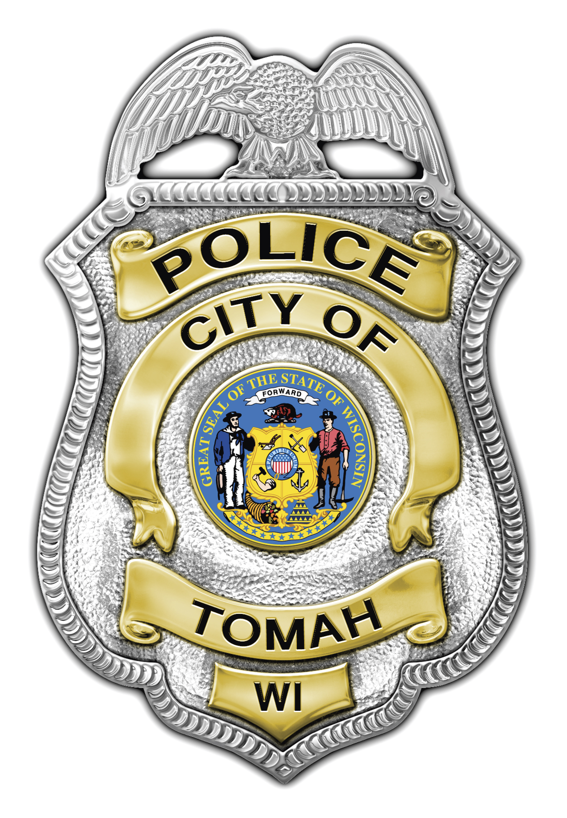
Wesley D. Revels
Chief of Police

_____________________________________________________________

August 10, 2010

The Tomah Police Department will mobilize along with other law enforcement agencies throughout Wisconsin for the annual “Drunk Driving. Over the Limit. Under Arrest.” crackdown on impaired motorists from Aug. 20 to Sept. 6.

This is the first statewide crackdown on drunken driving since a new law took effect on July 1 that significantly strengthens deterrents and increases penalties for operating a motor vehicle while intoxicated (OWI) in Wisconsin. The new state law increases jail time for many OWI convictions. In addition, it requires first-offense OWI drivers who were convicted with a blood/breath alcohol level of .15 or higher and all repeat drunken drivers to install an ignition interlock device (IID) on every vehicle that they own or have registered in their name. An IID, which measures breath alcohol levels, makes convicted drunken drivers prove they are sober before they can start a vehicle.

Throughout the state, drunken driving devastates individuals, families and communities. Alcohol-related crashes killed 238 people and injured 3,793 last year. There were approximately 45,000 convictions for drunken driving in Wisconsin in 2009.

Drunken driving is too prevalent and too deadly to ignore. That’s why we don’t give warnings or accept excuses for drunken driving. If you’re over the limit, you will be arrested. During the upcoming crackdown and throughout the year, our goal is not to arrest more drunken drivers. We simply are trying to save lives and prevent injuries. If we can deter people from getting behind the wheel when they’re impaired, we will make progress toward the goal of reducing the number of preventable traffic deaths to Zero In Wisconsin.

Sergeant Scott Holum

