Tomah Police Department

805 Superior Avenue

Tomah, Wisconsin 54660

Phone (608) 374-7400

Fax (608) 374-7413

tomahpd@tomahpolice.com
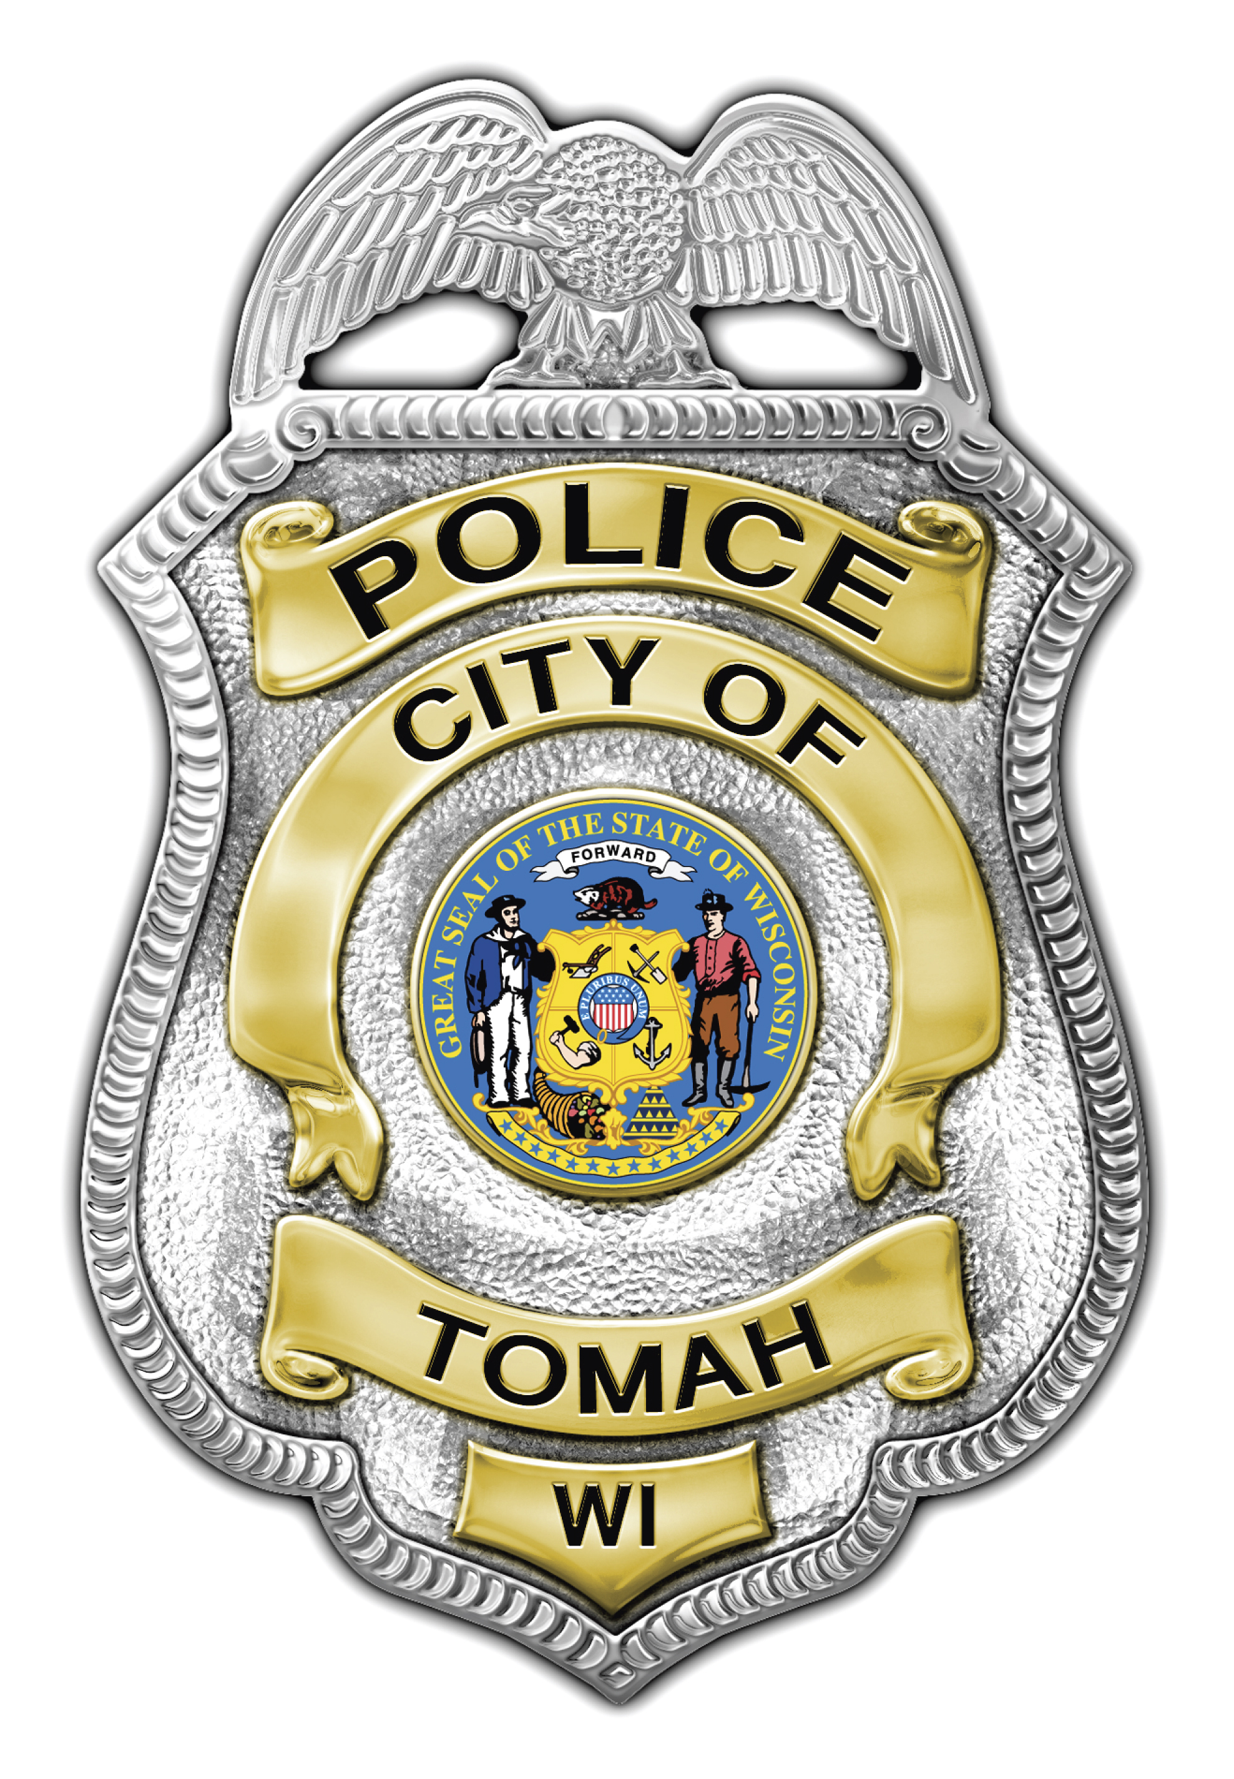
Mark D. Nicholson
Chief of Police

_____________________________________________________________

NEWS RELEASE

Incident Type: Death Investigation

Initial Incident Date: July 1, 2014

Incident Location: 219 Glendale Avenue

News Release Date: July 7, 2014

On Tuesday, July 1, 2014 the Tomah Police Department responded to 219 Glendale Avenue in the City of Tomah. Upon arrival a male subject, later identified as DERICK J. MCGOVERN (26-years-old), was located deceased in the residence. At the time officers were unable to determine a possible cause of death. There were no signs of trauma identifying cause of MCGOVERN’S death.

An Autopsy was ordered by the Monroe County Medical Examiner, and performed on July 2, 2014 by the University of Wisconsin, Department of Pathology and Laboratory Medicine. Pending a toxicology report, a cause of death was not determined.

The Tomah Police Department will provide updates as allowed, based on the needs of the investigation.

Released by:
Lieutenant Ron Waddell

