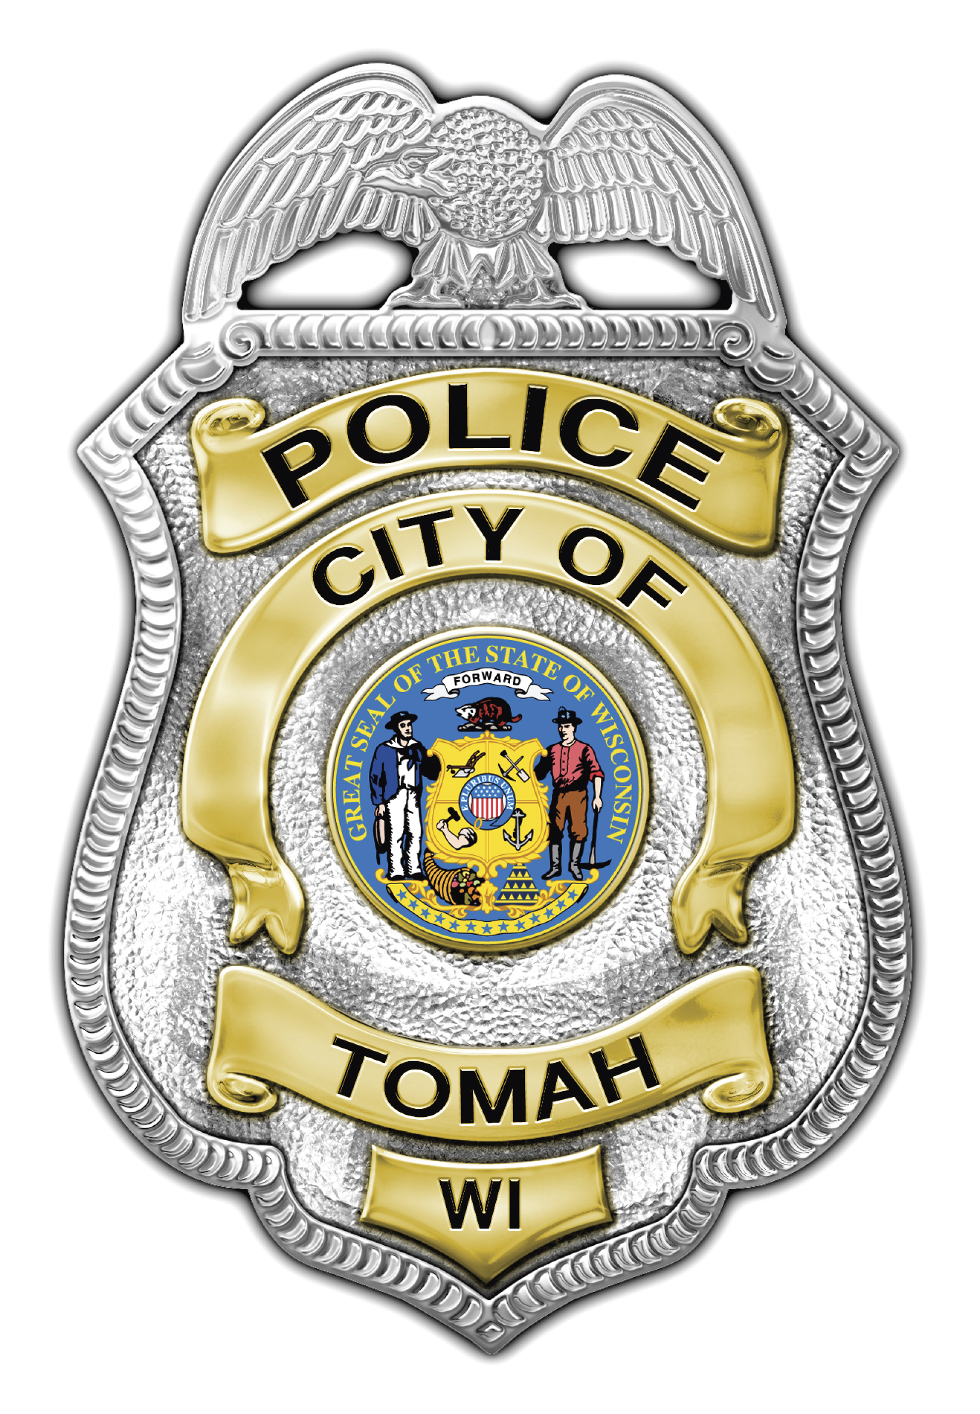
Mark D. Nicholson
Chief of Police

Tomah Police Department

805 Superior Avenue

Tomah, Wisconsin 54660

Phone (608) 374-7400

Fax (608) 374-7413

tomahpd@tomahpolice.com

_____________________________________________________________

NEWS RELEASE

On October 5, 2014 at 3:21 p.m. officers from the Tomah Police Department responded to a call of a deceased person who had been located in a residence. The residence was located on the 200 block of Hollister Ave in the City of Tomah. Upon arrival officers located a 23 year old female deceased. After conducting an initial investigation the cause of death could not be determined. The State of Wisconsin Mobile Crime Laboratory was called to assist at the scene.

The deceased has been identified as a Tomah resident however the name will not be released at this time.

The Monroe County Medical Examiner has ordered that an autopsy be performed. The autopsy is scheduled to be conducted today, October 6, 2014.

At this time there is no reason to believe that members of our community are in danger.

The Tomah Police Department was assisted at the scene by the Monroe County Medical Examiner's office, the Wisconsin Crime Laboratory, and the Monroe County Joint Investigative Task Force.

Mark Nicholson
Chief of Police
Tomah Police Department
805 Superior Ave.
Tomah, WI 54660
D - 608 374-7403
C - 608 343-7816

