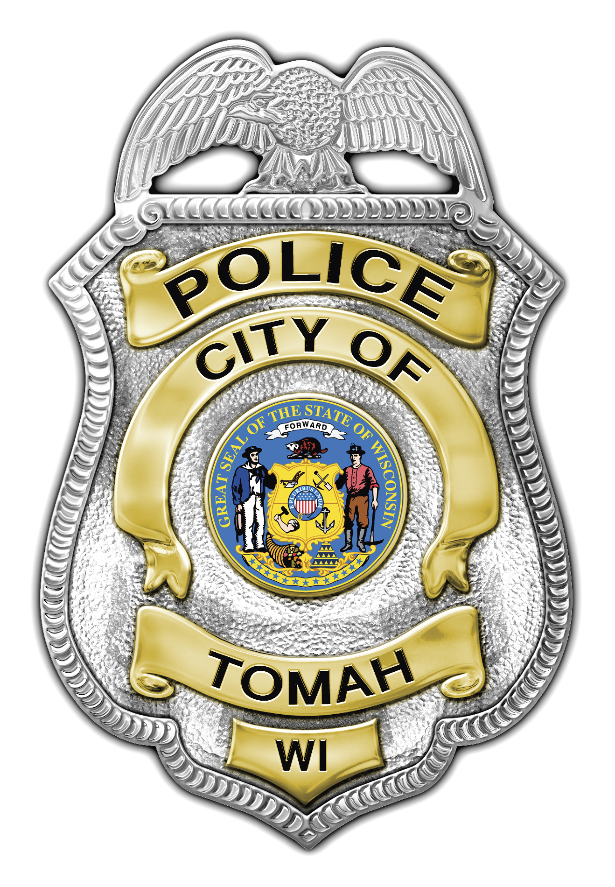
Mark D. Nicholson
Chief of Police

Tomah Police Department

805 Superior Avenue

Tomah, Wisconsin 54660

Phone (608) 374-7400

Fax (608) 374-7413

tomahpd@tomahpolice.com

_____________________________________________________________

NEWS RELEASE

Incident Type: Train vs. Pedestrian Crash

Incident Date: 08/30/14

Incident Time: 11:56 PM

Incident Location: Canadian Pacific Railroad Tracks / Superior Ave.

Victim/Suspect: Unidentified

Details: On 08/30/14 at approximately 11:56 PM an unidentified subject was on the Canadian Pacific Railroad Tracks approximately 100 feet east of Superior Ave. when the subject was struck by an eastbound train. The subject was located deceased at the scene by responding police officers.

The incident remains under investigation and no further information will be released at this time.

The Tomah Police Department was assisted at the scene by Tomah Area Ambulance Service, Tomah Department of Public Works, Tomah Fire Department, Monroe County Sheriff’s Department, Monroe County Medical Examiner, Wisconsin State Patrol and Canadian Pacific Railroad.

Release by: Sergeant Christopher Weaver
cweaver@tomahpolice.com

