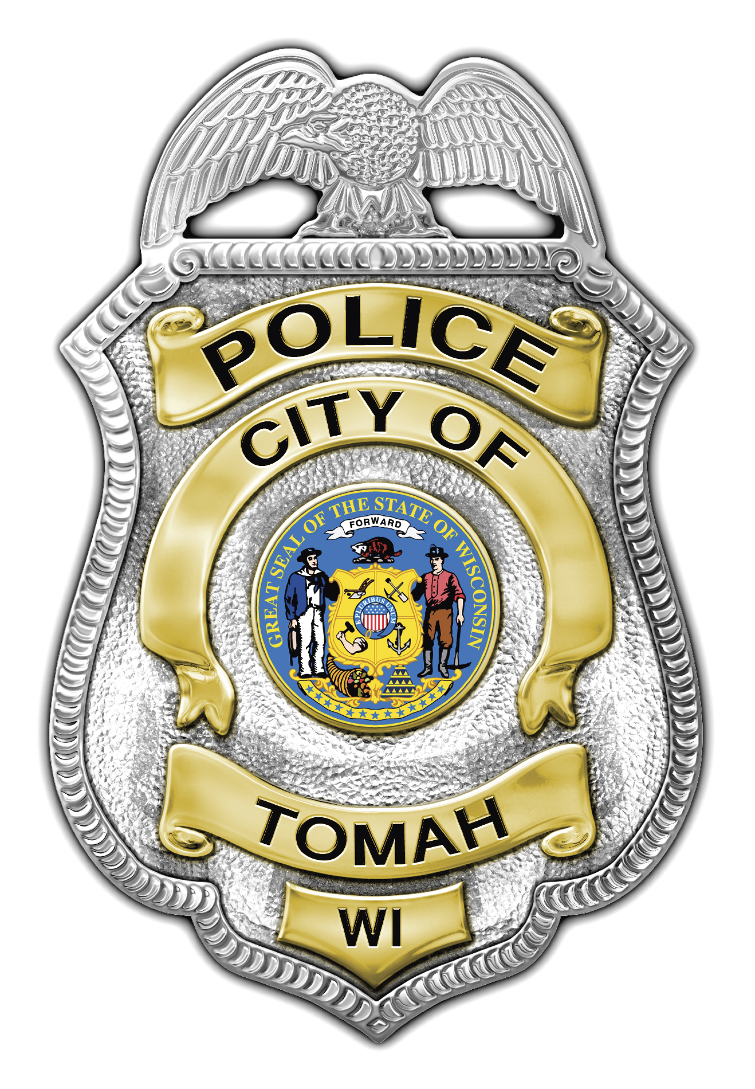
Wesley D. Revels
Chief of Police

Tomah Police Department

805 Superior Avenue

Tomah, Wisconsin 54660

Phone (608) 374-7400

Fax (608) 374-7413

tomahpd@tomahpolice.com

__________________________________________

NEWS RELEASE

Incident Type: Suspicious Activity

Incident Date: February 24, 2012

Incident Location: 1600 block of Hollister Avenue, Tomah

Incident Brief:

On February 24, 2012, at about 4:45pm, a 13 year old female was walking home when she was followed by a male and female in a vehicle. The subjects followed the juvenile at the pace she was walking for some time. When the juvenile became scared by their presence and actions she started to run. The subjects sped up in the vehicle to continue following the juvenile at the faster pace. When the vehicle eventually passed the juvenile the male driver threw a soda can out the window at the juvenile. The two subjects in the vehicle were laughing but there was no dialog between them and the juvenile.

The male subject was described as being approximately 50-60 years old with brownish gray hair and a longer matching beard.

The female was estimated to be approximately 30-40 years old with dark to black hair. There were no other identifiers for the female.

The vehicle was described as being a late model (1975-1990) Chevy “Shorty” van that was black in color. The paint on the van had a dull finish. There were no windows in the rear of the van. There was no license plate information available at the time of the release.

Anyone with any information on these two subjects or the whereabouts of a similar vehicle are asked to contact the Tomah Police Department.

Released By: Officer Hintz #91
ahintz@tomahpolice.com

